CST8503 Lab3 Prolog Programming

Overview
We build on your experience from Labs 1 and 2 to write and trace more prolog programs.

When you have finished this lab exercise, you will have the ability to
- Write complex structures using Prolog syntax
- Predict how two different structures with variables will be matched
- Use a graphical tracing utility to watch your programs execute

Complex Structures: points, line-segments, and rectangles

Create a new prolog program in a file called <your Algonquin ID>_Lab3.pl and be sure to include a header comment at the top explaining the purpose of the program.

We are representing an X-Y grid world where only certain points with integer-valued coordinates exist as defined by a point_exists/1 predicate. Write the procedures (predicates) described below, using the following functors. Do not define any other predicates. You are allowed to use the dif/2 built-in predicate whenever it is necessary to state that two things are not the same thing.
point_exists/1
seg_exists/1
triangle_exists/1
rectangle_exists/1

- Define the point_exists(P) predicate to state that (for now) exactly five points exist in our world, by writing down five statements, each stating that a different point exists (see the criteria in the next bullet). The argument P must be a point, represented by the function, point(X,Y). For example, point(1,2) denotes the point at X =1, Y=2. So if you wanted to state that point(1,2) exists, you would use the statement point_exists(point(1,2)).
- Ensure you satisfy the following criteria:
  - There is a declarative comment at the top, stating what the predicate means. In this case, it makes sense to use the wording “% point_exists(P) means that P = point(X,Y) is a point that exists at x-y coordinates X and Y.”
  - exactly two of the points have the same X-value,
  - no two points have the same Y-value,
  - no three points are on the same line (this makes the triangle_exists predicate simpler for us)
  - Write queries at the prompts below to test your point_exists/1 predicate
% test that succeeds
?
% test that fails
?-
% test that finds all points with a specific X value
?-
% test that finds all points that exist
?-

?- ['041107730_Lab3.pl'].
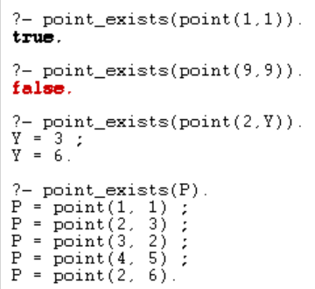

- Write a seg_exists(S) procedure which is true if the line segment S, represented by the function seg(X,Y), exists. S = seg(P1,P2) exists if P1 and P2 are two different points that exist.
  - Test your procedure using pairs of specific points (you should execute at least one test that prints false, and one that prints true)
?-
?-
  - Try your procedure with points that are not explicitly defined by the point/2 predicate.
?-
  - Use your procedure to find all line segments starting at a particular point (after each answer, type ";" to ask for more answers
?-
  - Use your procedure to find all vertical line segments (note that two points with the same X value form a vertical line segment)
?-
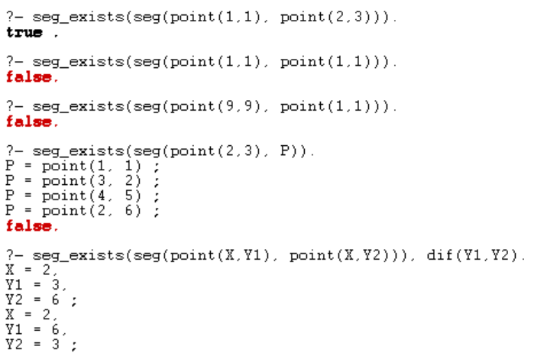
- Write a triangle_exists(T) procedure which is true if the triangle T, represented by the function triangle(X, Y, Z) exists. triangle(X,Y,Z) exists if X, Y, and Z are three different points that exist in your point set, forming a triangle. Note that as per the instructions above, no three of your points are on the same line, and this means you do not need to worry about the degenerate case of three points forming a straight line instead of a triangle.
  - Write three queries at the following prompts to test your triangle(T) predicate: two that succeed and one that fails:
?-
?-
?-
  - Write a query at the following prompt to use your predicate to find all triangles among your points:
?-
  - Write a query at the following prompt to use your predicate to find all triangles with a vertical side:
?-
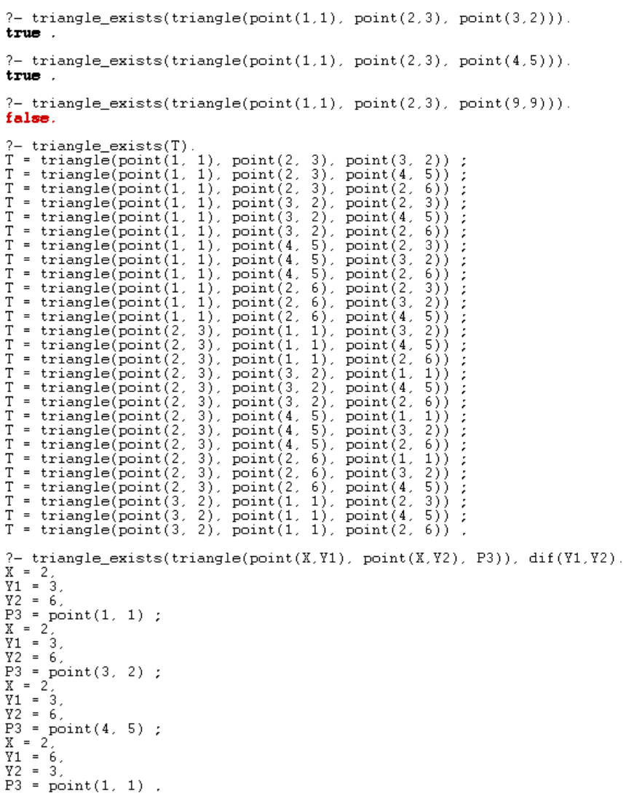
- Write a rectangle_exists(R) procedure which is true if the rectangle R, of the form rectangle(S1,S2) exists. It will exist if S1 and S2 are different line segments that exist such that
  - S1 and S2 are both vertical (do not define a vertical predicate – if the X value of the points the same, then it’s vertical)
  - The bottom point of S1 is at the same level as the bottom point of S2
  - S1 and S2 are the same length. Given the above two bullets, this means the top point of S1 is at the same level as the top point of S2. Do not actually calculate the length of line segments.
  - Add points as necessary to test your procedure, and write the queries you used for testing here:
?-
?-
?-
?-
?-
?-
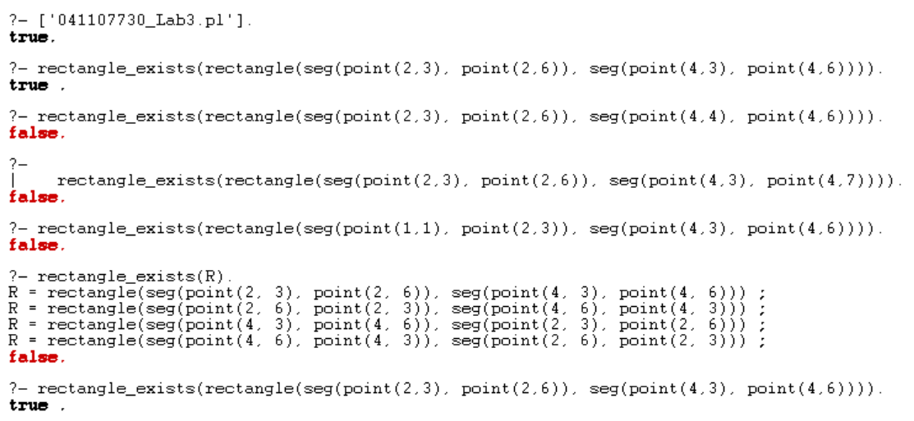

Submission

Submit your Prolog source file, AND this document with your queries filled-in.

Demonstration

Be prepared to
- Show your program with complex structures
- Run your program with a query that succeeds
- Run your program with a query that fails
- Explain to your instructor how two different structures with variables will be matched
- Show that you know how to use a graphical tracing utility to watch your program execute step by step

